*Integration of Diesel and Solar Powered Energy Sources to Supply an Off – Grid Residence*

*MECE 617 Activity*

Ivan John A. Naparota

University of San Carlos – Talamban Campus

Department of Electrical and Electronics Engineering

ivanjohnnaparota66@gmail.com

***Abstract* — this document presents a simple integration of solar energy source and diesel powered generator to provide energy for a single residence which is not connected to the main grid.**

***Keywords* – *Integration, Diesel – Powered Generator, Solar Energy Source***

# **I. INTRODUCTION**

A diesel generator is the combination of a [diesel engine](https://en.wikipedia.org/wiki/Diesel_engine) with an [electric generator](https://en.wikipedia.org/wiki/Electric_generator) (often an [alternator](https://en.wikipedia.org/wiki/Alternator)) to generate [electrical energy](https://en.wikipedia.org/wiki/Electrical_energy). This is a specific case of [engine-generator](https://en.wikipedia.org/wiki/Engine-generator). Diesel generating sets are used in places without connection to a [power grid](https://en.wikipedia.org/wiki/Electric_power_transmission), or as emergency power-supply if the grid fails, as well as for more complex applications such as peak-lopping, grid support and export to the power grid. Proper sizing of diesel generators is critical to avoid low-load or a shortage of power [1]. Knowing that diesel is being utilized to power this type of generation, carbon emission is inevitable, that is why incorporating renewable energy source like solar energy to the system can help lessen the emission of carbon to the atmosphere, not to mention the monetary savings we can get out from this initiative especially for a country like the Philippines that has a high cost for diesel fuel and any other products related to diesel.

On the other hand, solar power is the [conversion of energy](https://en.wikipedia.org/wiki/Energy_transformation) from [sunlight](https://en.wikipedia.org/wiki/Sunlight) into [electricity](https://en.wikipedia.org/wiki/Electricity), either directly using photovoltaic (PV), indirectly using [concentrated solar power](https://en.wikipedia.org/wiki/Concentrated_solar_power), or a combination. Photovoltaics were initially solely used as a source of [electricity](https://en.wikipedia.org/wiki/Electricity) for small and medium-sized applications, from the [calculator](https://en.wikipedia.org/wiki/Amorphous_silicon#Solar_cells) powered by a single solar cell to remote homes powered by an [off-grid](https://en.wikipedia.org/wiki/Off-grid) rooftop PV system. Commercial concentrated solar power plants were first developed in the 1980s. As the cost of solar electricity has fallen, the number of grid-connected [solar PV systems](https://en.wikipedia.org/wiki/Solar_PV_systems) has [grown into the millions](https://en.wikipedia.org/wiki/Growth_of_photovoltaics) and utility-scale [solar power stations](https://en.wikipedia.org/wiki/Photovoltaic_power_station) with hundreds of megawatts are being built. Solar PV is rapidly becoming an inexpensive, low-carbon technology to harness [renewable energy](https://en.wikipedia.org/wiki/Renewable_energy) from the Sun [2].

This project will make a simple simulation on the integration of diesel generator and solar photovoltaic in a single residence which is not connected to the grid, solar irradiance data were gathered from the database of NASA (National Aeronautics and Space Administration) available in the web and utilizes the load profile of a particular small residence.

# **II. METHODOLOGY**

***A. Design***

Design for the off – grid system will consider these varying parameters.

GENERATOR

|  |
| --- |
| RATING |
| 150 watts |
| 200 watts |
| 500 watts |
| 750 watts |
| 950 watts |

The cost considered for the generator is $136 per 1000 watts rating [4].

PHOTOVOLTAIC PANEL

|  |
| --- |
| RATING |
| 100 watts |
| 500 watts |
| 1000 watts |

The cost considered for the photovoltaic panels is $1500 per 1000 watts rating [5].

***B. Simulation with HOMER***

HOMER Energy is the global standard for optimizing microgrid design in all sectors, from village power and island utilities to grid-connected campuses and military bases. Originally developed at the National Renewable Energy Laboratory, and enhanced and distributed by HOMER Energy.

***C. Data Gathering***

*Schedule of Loads*

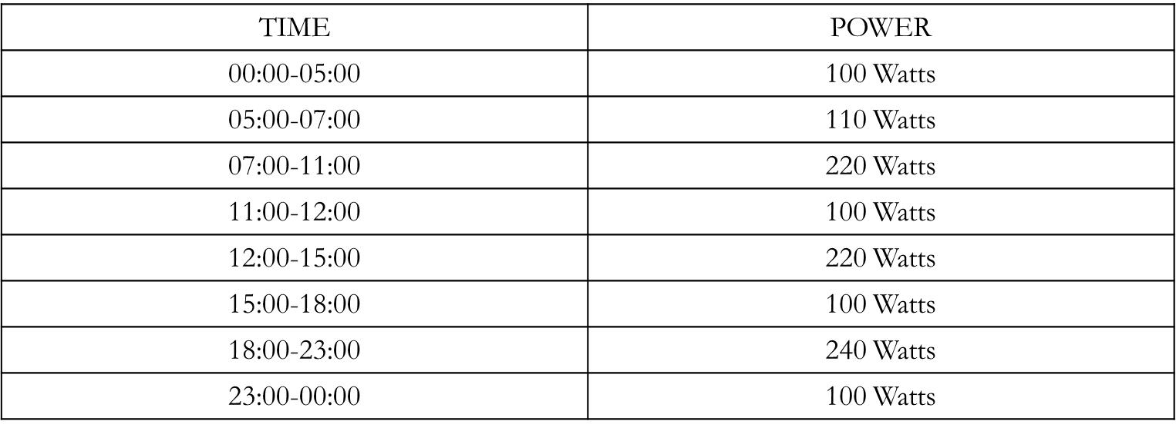

*Solar Irradiance*

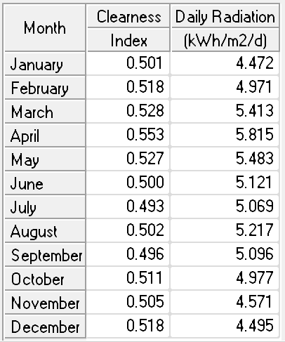*­*

*https://eosweb.larc.nasa.gov/cgi-bin/sse/grid.cgi?email=skip@larc.nasa.gov*

**III. RESULTS AND DISCUSSION**

Simulation in HOMER will give us the following results.

Possible designs for the system are presented below,

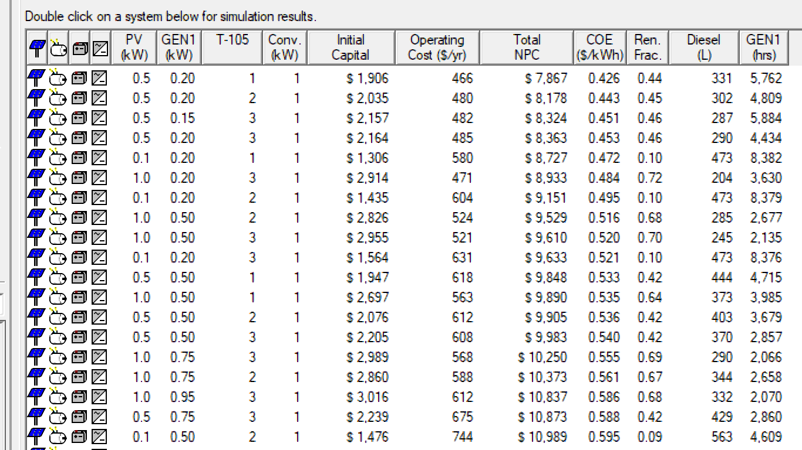

With these possible combinations, let us choose the system design that will give us the lowest COE (Cost of Energy), see the image below,

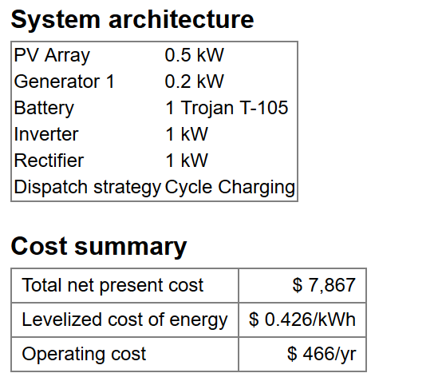

This system design that has the least Cost of Energy utilizes 500 watts Photovoltaic Array, 200 watts Generator powered by diesel, 1 piece Trojan T – 105 deep cycle battery, and 1,000 watts inverter/rectifier as you can see above. The system will cost us $466 per year to operate and $.426 per kWh as the cost of energy.

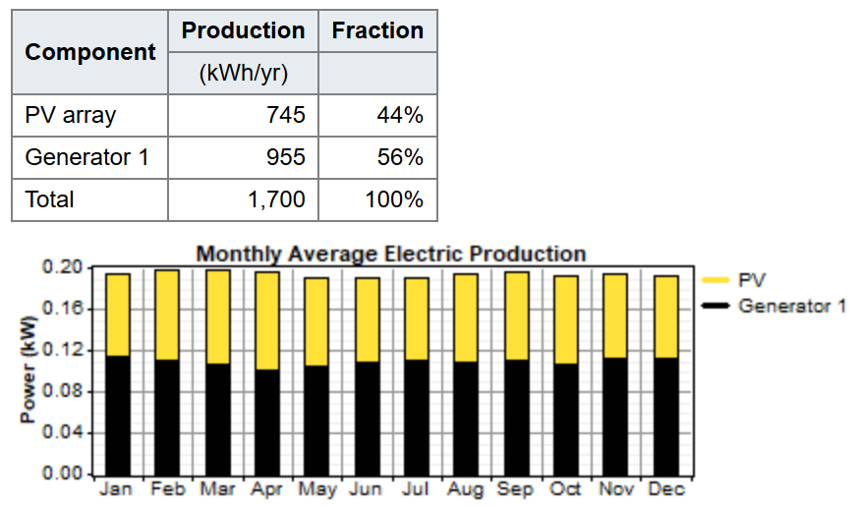

We can observe that the cost of energy is a bit higher than our regular energy rate in the Philippines, because as you can see in the image above, 56% of the energy usage comes from the diesel generator, and we should take into consideration that the cost of diesel fuel here in the country is a bit higher, this makes the output of our simulation for this particular design reasonable.

Now, let us take a look at this another design,

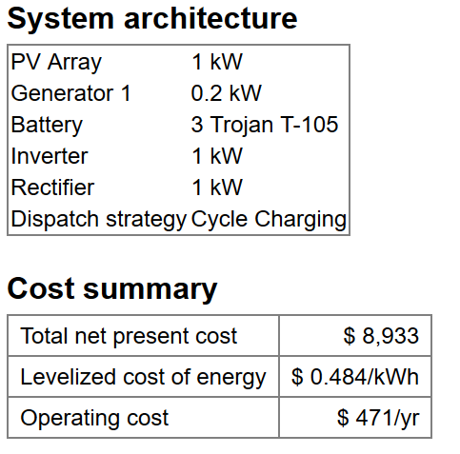

This system design utilizes 1000 watts PV array, 200 watts diesel generator, 3 Trojan T-105 deep cycle batteries, and 1000 watts inverter/rectifier, costing us $0.484 per kWh, though it has a higher cost of energy than the previous design, taking a look at its performance is perhaps useful for us to choose the right design.

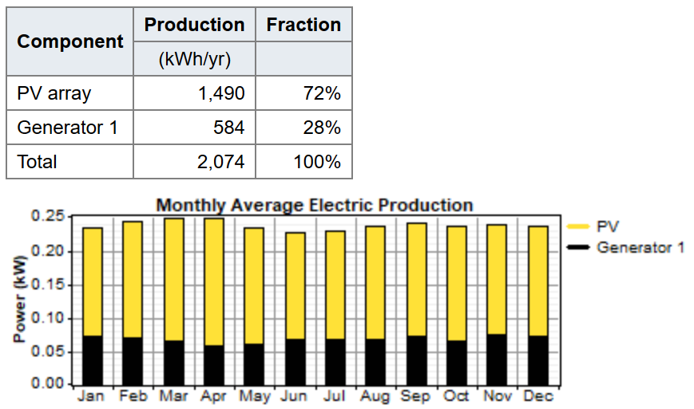

As observed in the image above, for this design, it utilizes more the energy coming from the sun than of the diesel generator, but why does we have a higher cost of energy? Perhaps it is because of the higher capital to put up this kind of design, it will take us a bigger rating of solar PV, and a bunch of batteries. What can we get from this design? Though the price of energy is higher, since this design utilizes more of its energy from renewable source, carbon emission is significantly lower than of the previous design, it may sound noble to consider the carbon emission of the design but it’s a “pick your poison” game right here, it is for us to decide what we think will be favorable for our intent. See the image below for the comparison on their carbon emissions.

DESIGN 1

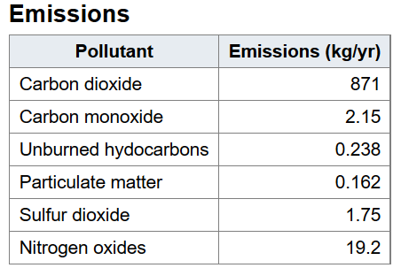

DESIGN 2

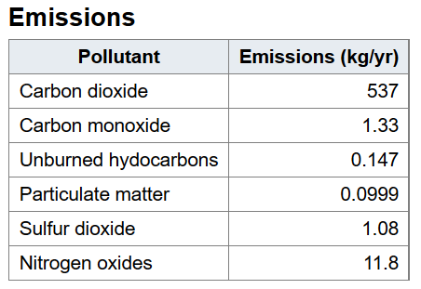

V. CONCLUSION

Considering the results presented, the first design that utilizes low cost materials will give us the least cost of energy but will give a significant amount of carbon emissions and the second design is the exact opposite, it will give us a higher cost of energy than the first one but it will deliver less carbon emission.

VI. REFERENCES

1. https://en.wikipedia.org/wiki/Diesel_generator.
2. ["Energy Sources: Solar"](https://www.energy.gov/energysources/solar.htm). Department of Energy. Retrieved 19 April 2011.
3. https://eosweb.larc.nasa.gov/cgi-bin/sse/grid.cgi?email=skip@larc.nasa.gov
4. https://www.lazada.com.ph/powergen-portable-generator-950-750w-red-265215.html
5. https://iprice.ph/home-improvement/solar-panels/